DATE: 20.04.2018
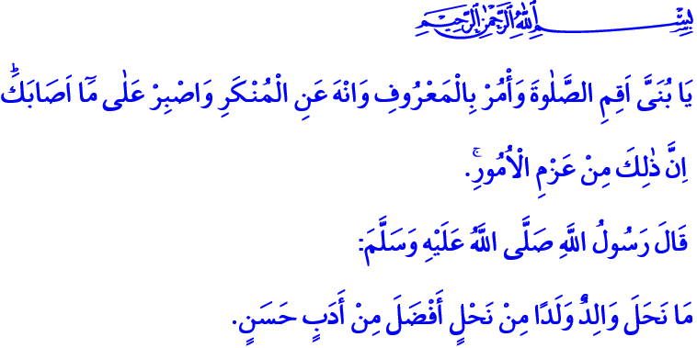
OUR HOPE FOR TOMORROW: CHILDREN
Jumu’ah Mubarak Honorable Believers!
Our beloved Prophet was fond of sharing the gifts that were given to him, starting from his right side. One day, as he was seated amongst his companions, he turned to his right to share a gifted drink. He saw that to his right was sitting the nephew of his uncle, Abdullah b. Abbas, who was a little boy at the time. To his left, the elderly amongst his companions were seated. The Prophet of Compassion (s.a.w.) did not wish to hurt the child’s feelings and without skipping the child’s turn asked him: “Do you permit me to give it to them (the old men)?”, but the boy said: “By Allah! I will not give preference at your hand over me in my share.” After this response, our Prophet began sharing the drink from the child.
Honorable Believers!
The Prophet of Allah (s.a.w.) always had a place for children in meetings and in masjids, valuing them as the “adults of tomorrow” and protecting their rights. For children are, as stated in the Qur’an, “an adornment of [worldly] life”, and as said by our Prophet, “acts [of good] which last after death.” Children are the prosperity of homes, hope of families and the future of society. They are the answer to prayers, “My Lord! Grant me from Yourself a good offspring.”, and a truly divine gift.
Brothers and Sisters!
We all hold responsibilities to our Lord, to each other and to our environment. One of our most important responsibilities is the ones we have towards our children. The Messenger of Allah (s.a.w.) who declared “Your child has a right upon you.” sought the Ummah’s attention on this issue. For children, though little themselves, have rights which should never be belittled. And it falls upon us adults, to protect the rights of children – entrusted to us by Allah for safekeeping.
Whether girl or boy, it is our duty to accept the arrival of a children wholeheartedly, to welcome them with love and prayers. It is our responsibility to give children pleasant names, to show them the attention and compassion they deserve, and to be just by not showing favoritism between siblings.
We should raise our youngsters on halal and healthy food, pay attention to their education, and provide for their spiritual needs as well as material ones. We should guide our children in being introduced to social life, familiarizing them with their culture and teaching their customs and traditions. For the social and cultural development, bodily and mental education and religious and moral upbringing of children begin in the family. The dutiful generations that are our hope for tomorrow shall be the product of conscious parents. Let us not forget that a child who is made to suffer and whose rights are violated cannot appreciate the value of justice. A child hammered under violence cannot comprehend the meaning of mercy. A child who is humiliated and whose personality is ignored cannot build a healthy future.
Esteemed Believers!
Our best guide in children’s education and in communication with children is our Prophet. He respected the honor children carried as human beings. He made them feel that they are valuable, greeted them on the street, asked how they were, and answered their questions. He would kiss and hug them, embrace them and play with them without heeding anybody’s disapproval.
Allah’s Messenger (s.a.w.) forbade speaking by evil words and cursing towards children. He prayed for all children who came to him or were brought to him. He paid special attention to the religious education of children, never turned them away from his masjid to raise mosque and worship-loving generations.
Honorable Muslims!
Let us heed the words of our Beloved Prophet claiming, “There is no gift that parents give their children more virtuous than good manners.”. Let us take example of him, and use his education methods based on compassion and justice, patience and tolerance. Let us facilitate the opening of the doors of peace, success and beauty in this life and in the next for our children.
Luqman (a.s.) advised his son: “O my son, establish prayer, enjoin what is right, forbid what is wrong, and be patient over what befalls you. Indeed, these matters require determination.” Let us always stand by our children and hold their hands like him.
I wish to end this khutbah with a prayer from the Qur’an: “Our Lord, grant us from among our wives and offspring comfort to our eyes and make us an example for the righteous.”

Muslim, Ashriba (the Book of Drinks), 127.
Kahf, 18/46.
Muslim, Wasiyyah (the Book of Wills), 14.
Al-i ‘Imran, 3/38.
Muslim, Siyam, 183.
Muslim, Salam, (the Book on Greetings), 14.
Tirmidhi, Birr (the Book on Righteousnes), 58; Ibn Hanbal, IV, 77.
Luqman, 31/17.
Furqan, 25/74. General Directorate of Religious Services

